This is for the lightgaussrifle.data{gamemodel}

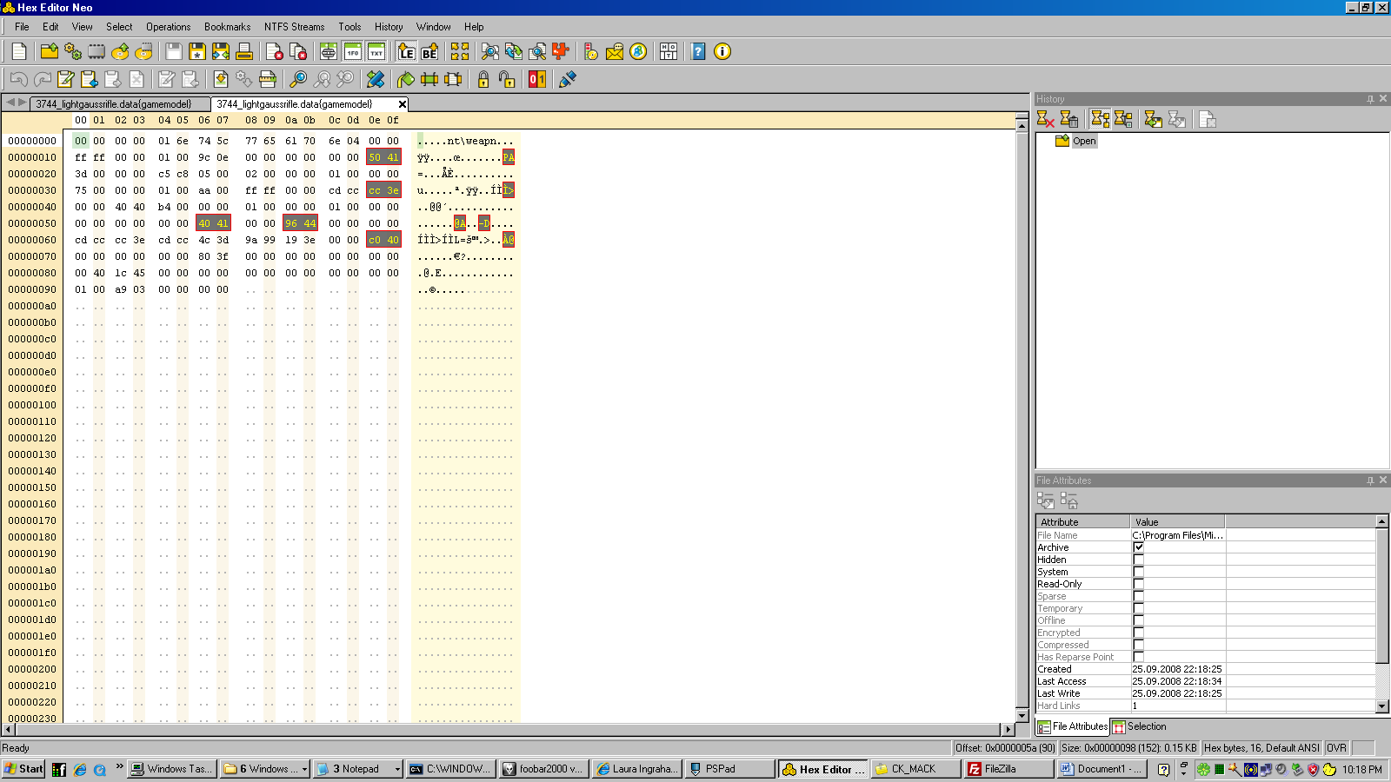

1e-1f – weapon weight.

3e-3f – heat

56-57 – damage

5a-5b – range

6e-6f – recycle

The first byte in the sequence is the least significant. A lot of these values don’t translate into recognizable decimal values. I guess the proper term is a floating interger. For example the values for range in a light gauss rifle are 96 FF which is displayed as 1200 meters in the game. But I don’t think 96 FF converts directly to a 1200.

